Welcome in Day 3 notes

Chapter 5.

Classes, viewProviders & Interpolation

1. Classes
2. View Provider
3. Interpolation

Difference between class of module and class of component

Class of module is central government(modules rules will be get attached to every component)

Class of component is state government(component class will be just for component)

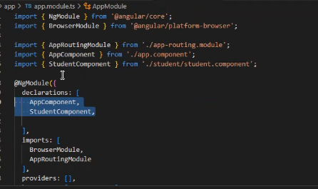

Activity to follow

Add console below all imports of module and component

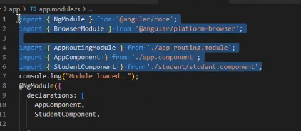

You will see Module loaded first then component so why we don’t load this class only?

What is the use of component level classes

Ex- On amazon website if payment class is module level then without doing payment order will be placed so instead they add payment received class on “confirmPayment.component.ts”

Decorator creates object of class, which is exactly below of it only. Without constructor

Memory management in angular is automatic, methods to create object in class

There are two methods to create an object in angular (Interview)

msg = new msg(); -> This method is problematic because it takes different memory place

so we use following method so memory management will be automatic

constructor(private obj:msg){

obj.show() -> Whatever its output will be shown

}

After calling its object constructor will automatically called.

How to use module level class on component level

Use View provider:[classname]

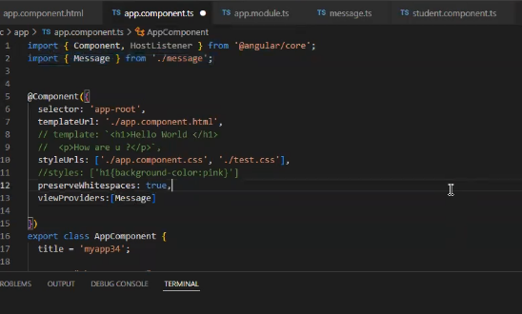

Whenever you want to use any class in component level then use viewProvider

There is on more way but in it we would be use that component on the same component only

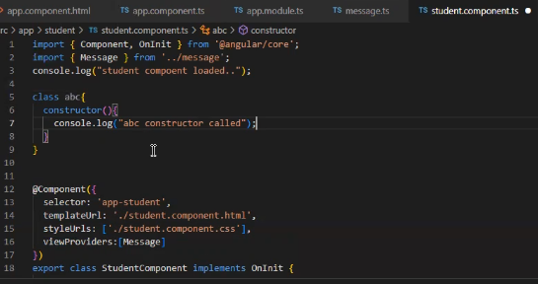

Whichever class I want to use it in component level should be placed in viewProviders

Providers is used for services

Activity to search

Is component a class?

Complete viewProviders in following snapshot

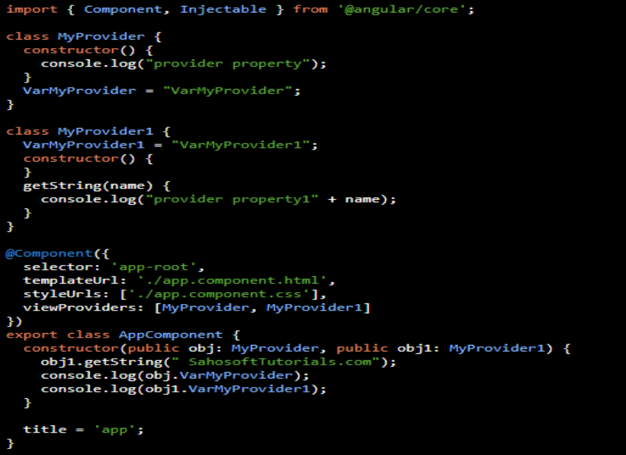

Interpolation

Data Binding

that allows us to communicate between the component and its view. The data binding can be a one-way data binding [angular interpolation / string interpolation, linking properties, event linking] or a two-way data binding

In the one-way data binding, the model value is inserted into an HTML element (DOM) and the model cannot be updated from the view. In the two-way binding, the automatic synchronization of data occurs between the Model and the View (each time the Model changes, it will be reflected in the View and vice versa)

Any of the class level variable cannot be used directly in method, we need to use this method

Ex- this.changedate

Interpolation

Interpolation is a technique that allows the user to bind a value to an element of the user interface.

See whatever data is there in .ts file using it in html is called Interpolation.

We can simply write any method

In ts file

Methodname{

Name: ‘Rajan’

City: ‘pune’

}

Using it in html

My details are {{“telling my native:” +methodName}}

Want something specific then

Name : {{methodname.Name}}

We can do athematic operations in interpolation

Ex- in ts

Num1=10

Num2=20

Now in html

Answer is: {{Num1 + Num2}}

How to use

{{methodname}}

If no data available in Name for example then error handling can be done in interpolation

Name : {{methodname && methodname.name}} -> Like we use in gates if both true then output same concept in angular as well

Name: {{methodname ?.name : ‘No Data Available’}} -> if data is there then printed otherwise left without printing